MC900349465[1]Name Period Date

**Engineering an Empire: Greece**

#### Introduction ~ Themistocles

1. 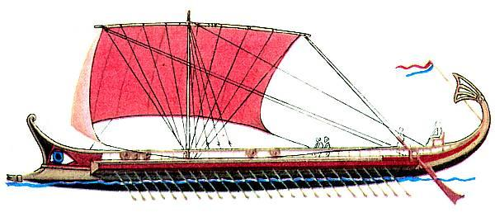What is the greatest empire the world has ever known that lies just outside of Greece?
2. Who is the one Greek poised and ready for battle against Persia?
3. What is a self-contained, self-reliant mini country within Greece?
4. What is the offensive weapon of the Trireme? How fast could it go (knots)?
5. Some historical sources claim that the Persians lost as many as _______ ships to the Greeks _______.

#### Mycenaean Civilization

1. MC900037388[1]According to myth, Agamemnon’s epic struggles were written down by ____________, in two of history’s most famous tales, The Iliad & the Odyssey.
2. For awe-inspiring visuals, nothing comes closer than what colossal main entrance to the citadel?
3. What was the corbel dome used for?

#### The Tyrant Polycrates

1. Around 540 BC a tyrant named Polycates came to rule what island?
2. What problem did Polycrates set about to solve that plagued many cities in the arid climate?
3. What did the Persians do to Polycrates when they thought he was getting too much autonomy?

#### MC900233985[1]Pericles and the Golden Age

1. What everlasting monument is Pericles everlasting legacy?
2. When Themistocles defeated the Persians at the battle of Solomus, he saved not only Athens, but also its young _______________.
3. In 478 BC, Athens, together with the city-states of the Aegean formed a mutual defense alliance called the Delian League. The ancient world’s version of __________.
4. What two Greek mythology gods does the narrator reference in the creation story of Greece?

#### Parthenon

1. MC900412994[1]Explain the saying “There are no straight lines in the Parthenon.”
2. What was the Parthenon meant to represent?
3. Which of Athens’s long-time enemies felt threatened and went to war with Athens?
4. What was the invisible enemy that took the lives of many Athenians?
5. Who won the Peloponnesian War? Why was it important?

